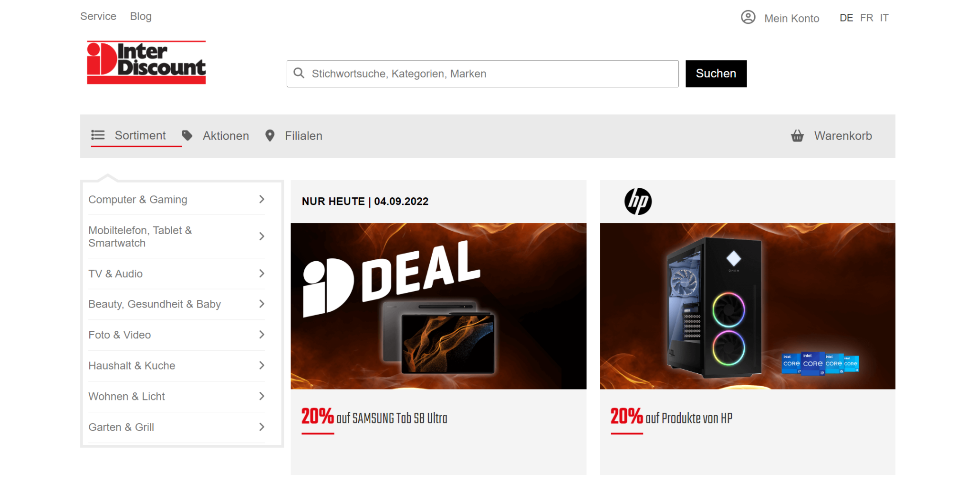

In this exercise our priority is creating main layouts and applying necessary responsive layouts and styles.

First of all you need to use flex layouts to create a responsive webpage.

There are three break points: 992px, 768px and 576px.

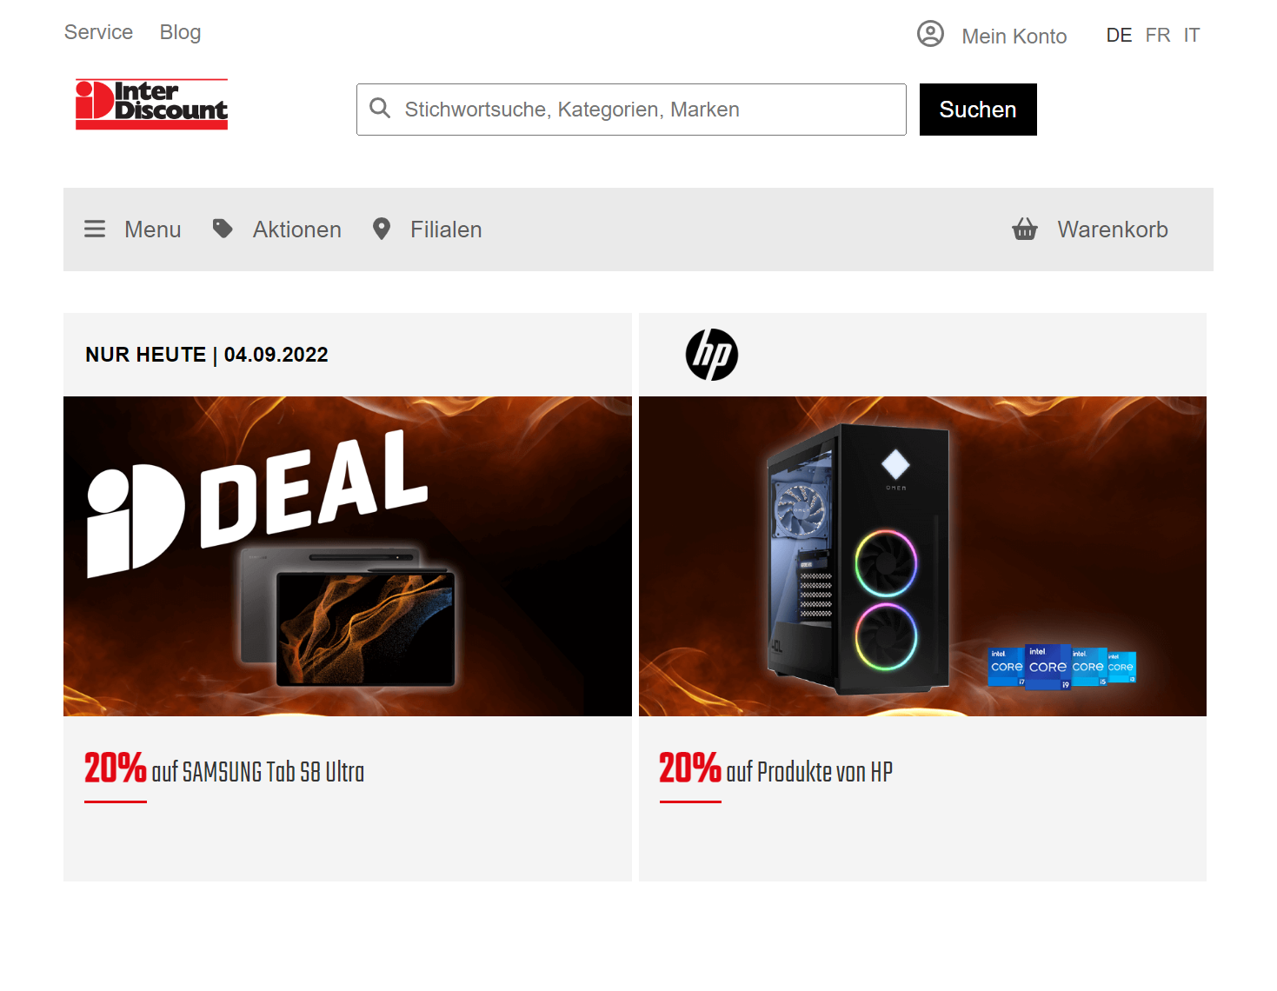 **As you see in the first breakpoint (992px)**

- The sidebar(item category menu) will disappear.

- Item contents will cover all width.

- Also logo of Inter Discount will get more smaller (120px*40px)

- The **sortiment** block will be removed.

- The **Menu** block will be placed instead of sortiment.

**The second breakpoint will be at 778px.**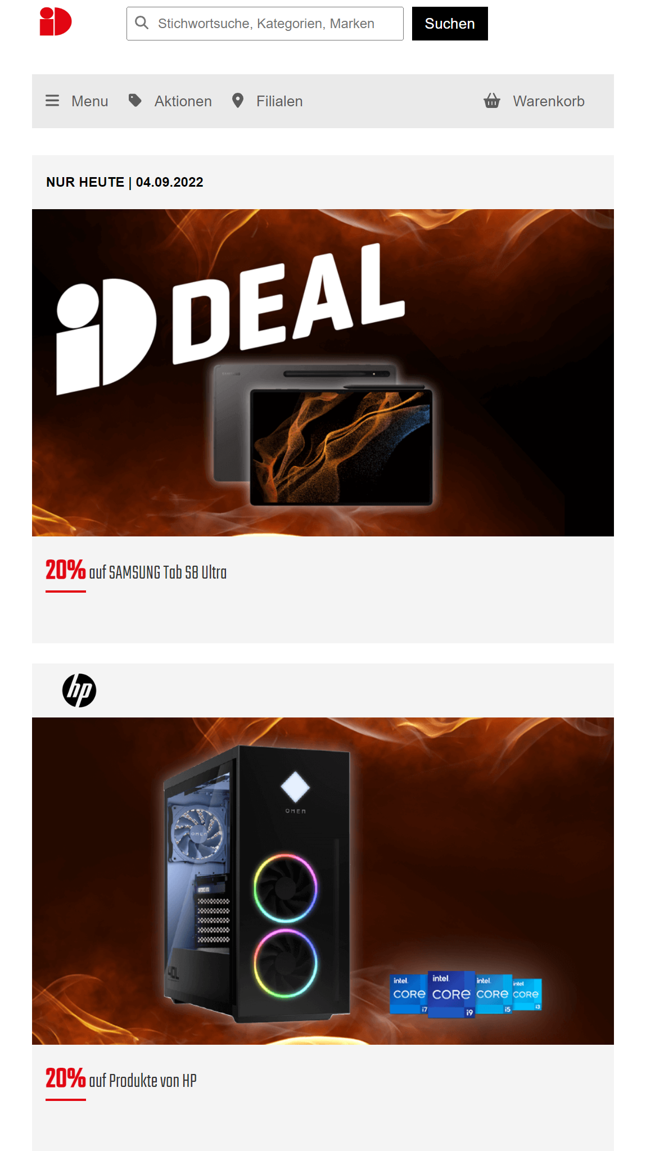

- The logo of Inter Discount will be altered.

- In the content field,there would be one item in a line.

- The navigation bar which is at the top will disappear.

**The third breakpoint will be at 576px.**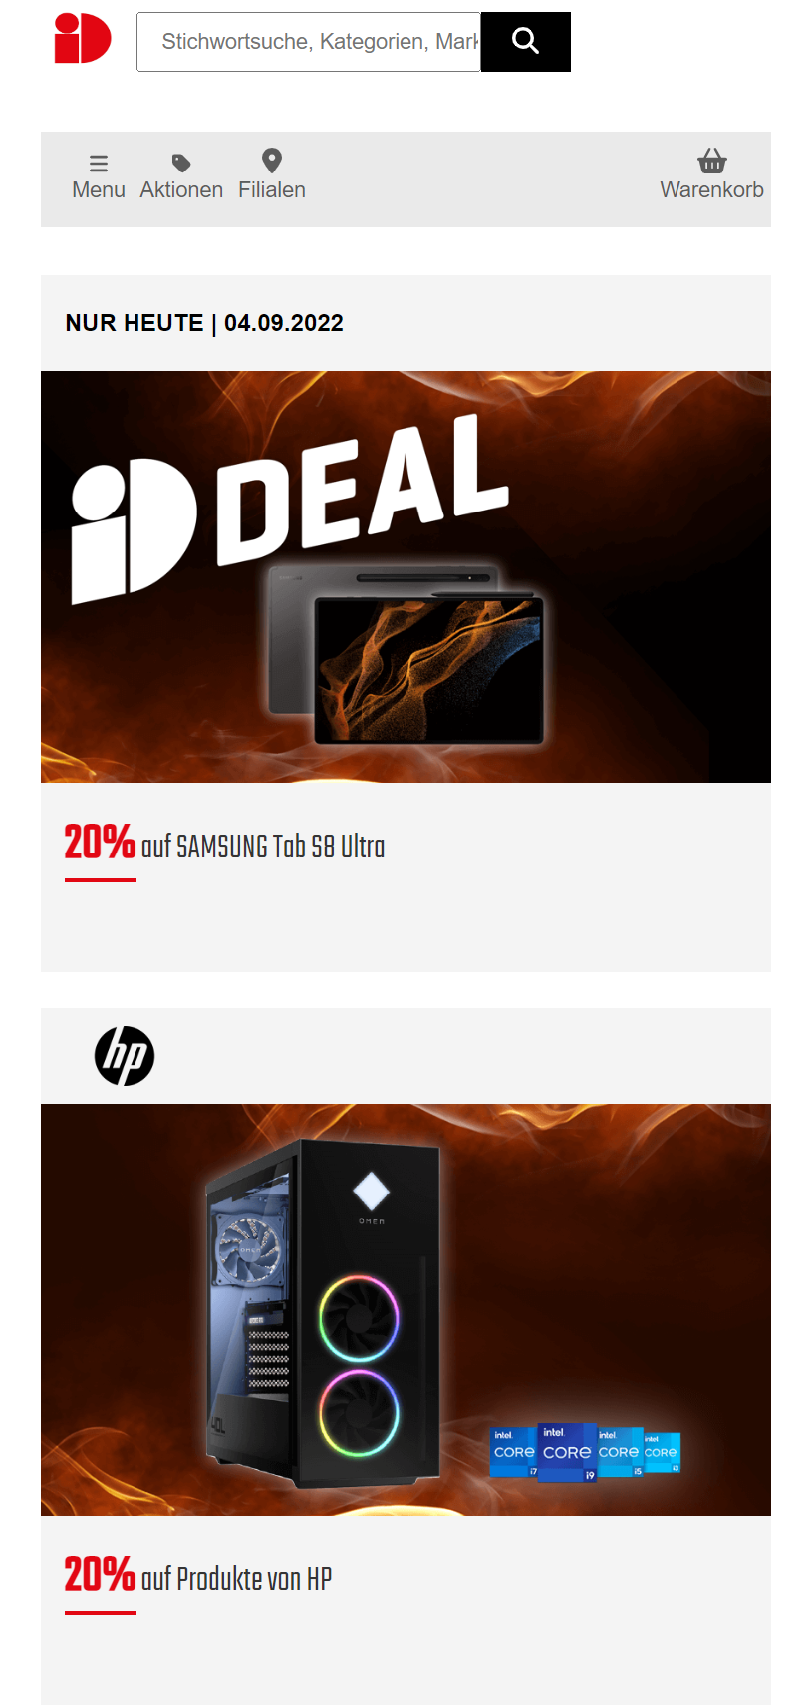

- In the previous pictures you will see a magnifier icon inside the search input. At this breakpoint you need to remove this icon.

- Later, you need to change the search (suchen) button as it is seen in the picture.

- Lastly, you need to change the layouts of the menu items and icons.

**Mobile View**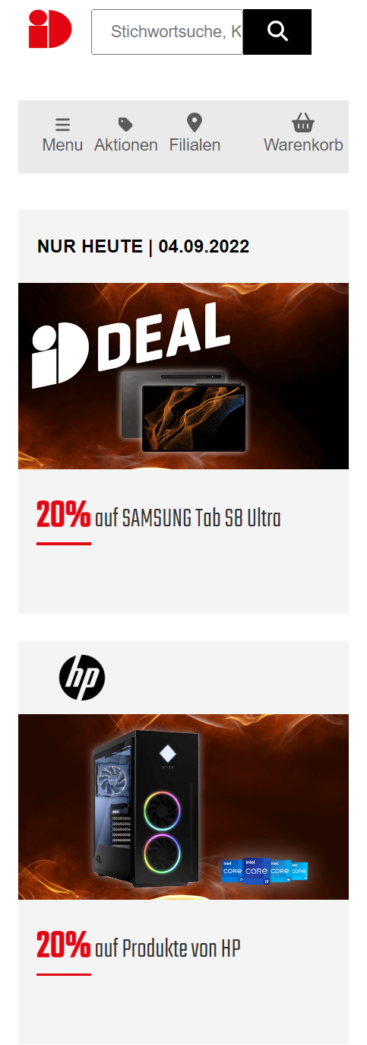

Your page has to be responsive. The responsiveness should last till 300px.

**Good luck!**